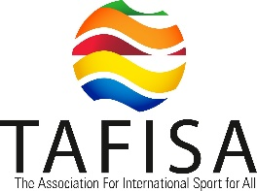
Release date: [add expected date of release]

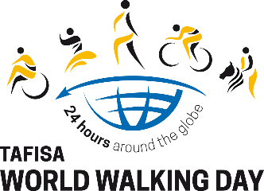
[add your organisation’s logo]

TAFISA World Walking Day – 24 hours around the globe;
Join the most accessible and inclusive relay around the world
On Sunday 3 October 2021, people and organisations will pass the baton across all time zones from east to west to celebrate the power of sport and physical activity in unifying the world. [Your organisation] is proud to represent [your country and/or community] in this global event.
Over the past three decades, millions of participants have taken part in 160 countries. In 2020, the event became TAFISA World Walking Day – 24 hours around the globe and turned the traditional walking event into a global relay encouraging active movement. Dozens of thousands hailing from 65 countries on all continents took part and shared powerful messages of peace, access to sport and education for all, gender equality, health, and solidarity against COVID-19 among many other causes, working together to create the most inclusive and accessible 24-hour relay.
This year, the TAFISA World Walking Day – 24 hours across the globe, invites global citizens to once again stand together and stay connected as a united front. The event will take place everywhere on Sunday 3 October 2021 from 10am local time, connecting people by creating a wave across the world from east to west and covering all 24 time zones.
[Add information on what your organisation is doing for the event and how people can join.]
[Add quote from your organisation’s representative on what joining the TAFISA World Walking Day – 24 hours around the globe means to your organisation]
The event aims to be the most accessible and inclusive 24-hour relay around the globe. Anyone can join by choosing their favourite active movement (walking, running, cycling, swimming, canoeing, skateboarding, climbing, horse riding, surfing, etc.) and sharing photos or videos passing the baton on social media with the hashtag #worldwalkingday. This flexible format encourages participants to raise awareness and support a cause or charity of their choosing. People are invited to register their participation for free on the TAFISA website and receive resources and support to be part of the global event.
More information about the TAFISA World Walking Day – 24 hours around the globe and how to participate: www.worldwalkingday.org
More information about [your organisation]’s participation in the event: [your website or article]

About TAFISA
As the leading international Sport for All organisation, TAFISA (The Association For International Sport for All) is in the privileged position to bring joy, health, social interaction, integration and development to communities and citizens around the globe through the promotion of Sport for All and physical activity. TAFISA aims to create a better world by unfolding the potential of Sport for All and physical activity globally and maximising its contribution to overcoming the world's global challenges.
TAFISA has over 360 member organisations in more than 170 countries on all continents. TAFISA actively cooperates with other global change-makers, including the UN, WHO, UNESCO, the IOC, ICSSPE and others, in their mission to create a Better World.
Founded in 1991 in Bordeaux, TAFISA is a non-governmental, not-for-profit organisation according to German law and registered at the law court in Frankfurt, Germany.
More information on TAFISA’s website: www.tafisa.org
About [your organisation]
[Your organisation]….

Contact
TAFISA:
www.tafisa.org
Gaëtan Garcia
Communications, Marketing & PR Manager
+49 69 97 39 35 99 3
garcia@tafisa.org
TAFISA Office, c/o Commerzbank,
Hostatostraße 2, 65929
Frankfurt am Main, Germany
Twitter: @TAFISAOffice – https://twitter.com/TafisaOffice

[Your organisation]:
[contact details for your organisation]

